**Prefer Immutability**

1. **Bad Practice:**



There are few use cases in which we know that the values in the list will not change. Here, considering the parking Lot will not change, using a mutableList may create confusion if a new value is added to the list by mistake or a value is removed.

**Good Practice:**



When we know that the data in the list is constant, then use a immutable List.

1. **Bad Practice:**

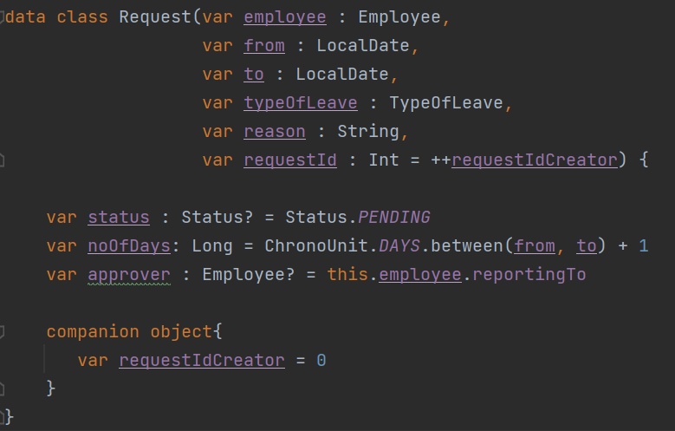

Here all the member variables of the data class are given as var. So its value can be changed later, but once a leave request is made all the variables other than status should not be allowed to be modified.

**Good Practice:**

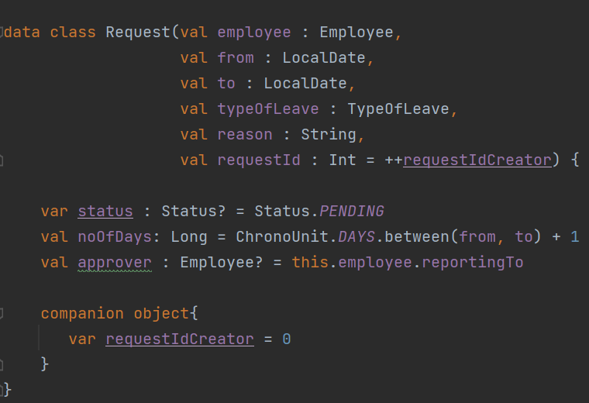

To achieve this, all the member variables except status should be val and status should be var.